
Steam Turbine
Description

The emergency stop valves and HP control valves arranged beneath the turbine operating floor in front of the turbine-generator unit are suspended at three points from girders in the upper foundation plate in such a way that they can follow thermal expansion of the steam lines.
The ball-and-socket design of the tie rod ends (5) and spring body (9) and the disc spring stack (8) arrangement permit free

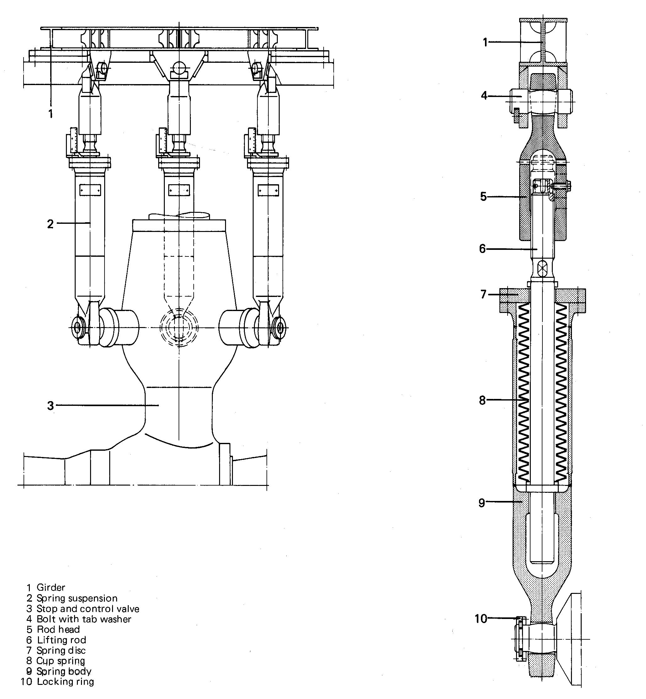

Suspension of Valves

movement of the emergency stop valves and control valves (3) in all directions. Tensile forces are taken up via the disc spring (8) and mandrel (6) by girders (1) that rest horizontally on shims in a recess in the foundation and are connected to the foundation via clamping plates. Tie mandrel (6) is screwed into tie rod cap (5) and when the correct elevation of the emergency stop valve and HP control valve (3) has been established, is secured to prevent turning.

BHEL Hardwar 5.1-0815-02

