
Steam Turbine Overspeed Trip Release Device
Description

Function
The function of over speed trip release device is to open the auxiliary trip oil circuit and thereby shutdown the turbine when pre set value of over speed is reached which would subject the rotor system to a dangerously high centrifugal force.

Construction
Over speed trip release device is mounted in bearing pedestal. The over speed trip release device consists of casing (5), the pilot valve (4) and pawls (7). The spindles (2) resting against the pilot valve actuate the limit switches (10). Pilot valves & pawls are latched through the auxiliary start up oil during the start up of machine.

Trip through the emergency /over speed governor:
If the pre set value of turbine over speed is attained, then the eccentric bolts/strikers come out from the emergency governor body (9), thereby striking/hitting on the pawls (7) and tilting pawls against the force of springs (6). The latches of pawls with pilot valves get released and so the pilot valves move outside towards the emergency governor by the force of the auxiliary trip oil pressure x and the spring loaded spindles (2). This process connects the auxiliary trip oil x with adjacent return oil flow ‘c ‘ thus causing the turbine trip due to drop in auxiliary trip oil pressure. The electrical

signal of the actuation of over speed trip release device is transmitted to the control room by the limit switch (10).

Movement test of speed monitor
The proper functioning of emergency/over speed governor is of utmost importance as severe damages may result from excessive over speed of turbine. The “emergency/over speed testing” described in a separate section which facilitate a testing of emergency governor without interruption of turbine operation is used for checking the movement of emergency/over speed governor strikers/bolts and the pilot valves and rods.

Start- up
If turbine is tripped due to actuation of emergency governor, then the over speed trip release device must be latched again before restating of the turbine. For this the auxiliary start up oil ‘u’ is supplied to the pilot valves through casing. In turn pilot valves move inwards by the force of auxiliary start up oil until these engage with the latch of the pawls. The supply of auxiliary start up oil is interrupted after the engagement and the auxiliary start up oil present in this space is drained via a bore into the bearing pedestal.

Section A-A
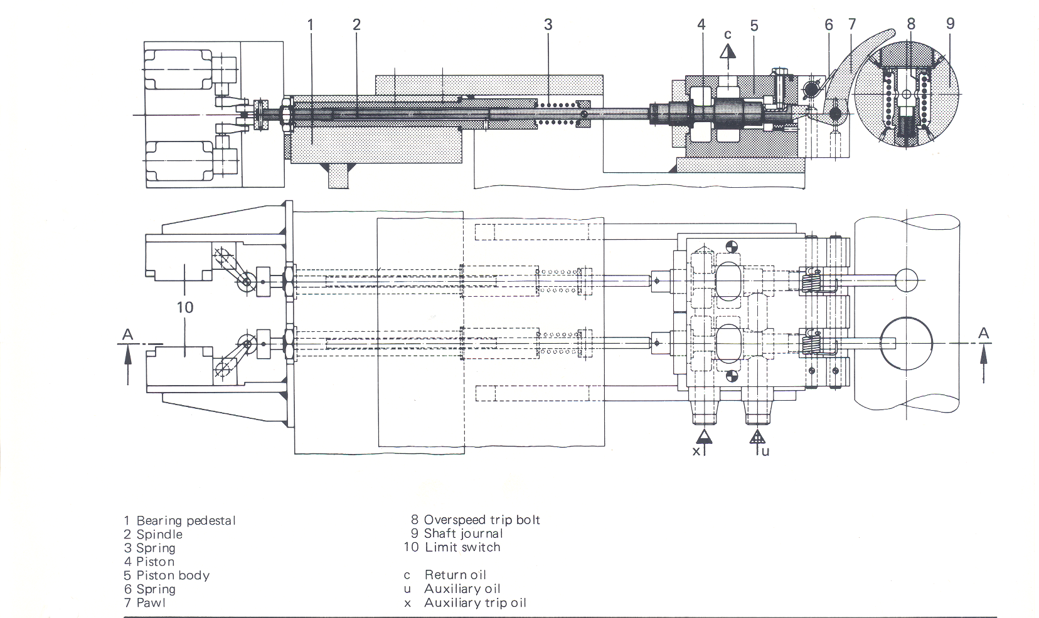
1 Bearing pedestal 6. Spring c Return oil
2 Spindle 7 Pawl u Auxiliary start up oil
3 Spring 8 Striker / Bolt x Auxiliary trip oil
4 Pilot valve 9 Emergency trip governor body
5 Casing 10 Limit switch

BHEL HARBHEL HARDWAR 5.1-0921-01

