
Steam Turbine Condenser Steam Dump Stop valve Servomotor
Description

Function

The function of the CSD (CONDENSER STEAM DUMP) stop valve servomotor is to operate the CSD stop valve according to the signals from the bypass controller.

Mode of Operation

The CSD stop valve is controlled by the piston (12) and piston rod (11) according to the position of the pilot valve (8). The piston is loaded on the one side by the disc springs (13) and on the other side by the control oil ‘a’. When the signal oil ‘b’ is not pressurized, the pilot valve (8) remains in the end position as shown due to the force of spring (5) . This means that control oil ‘a’ can not flow under piston (12) and the CSD stop valve is closed by force of the disc spring.
When bypass signal oil is fed to connection ‘b’, the pilot valve is lifted and control oil ‘a’ can flow under the piston (12) and the CSD stop valve is opened. The upper end of the piston rod enters a passage in the hood filled with oil so that the CSD stop valve can open softly.
When the pressure of the signal oil ‘b’ under the pilot valve (8) is reduced, the space under the piston (12) becomes depressurized due to the change in pilot valve position and thus the CSD stop valve is closed by the force of the disc springs (13). Just before the valve cone seats, the piston enters a recess in the casing bushing and throttles the return flow of the control oil under the piston. The closing movement is slowed so that the valve cone seats softly.
The pre-tensioning of the spring (5) and thus the signal oil response pressure can be adjusted by means of the threaded bolt (3).

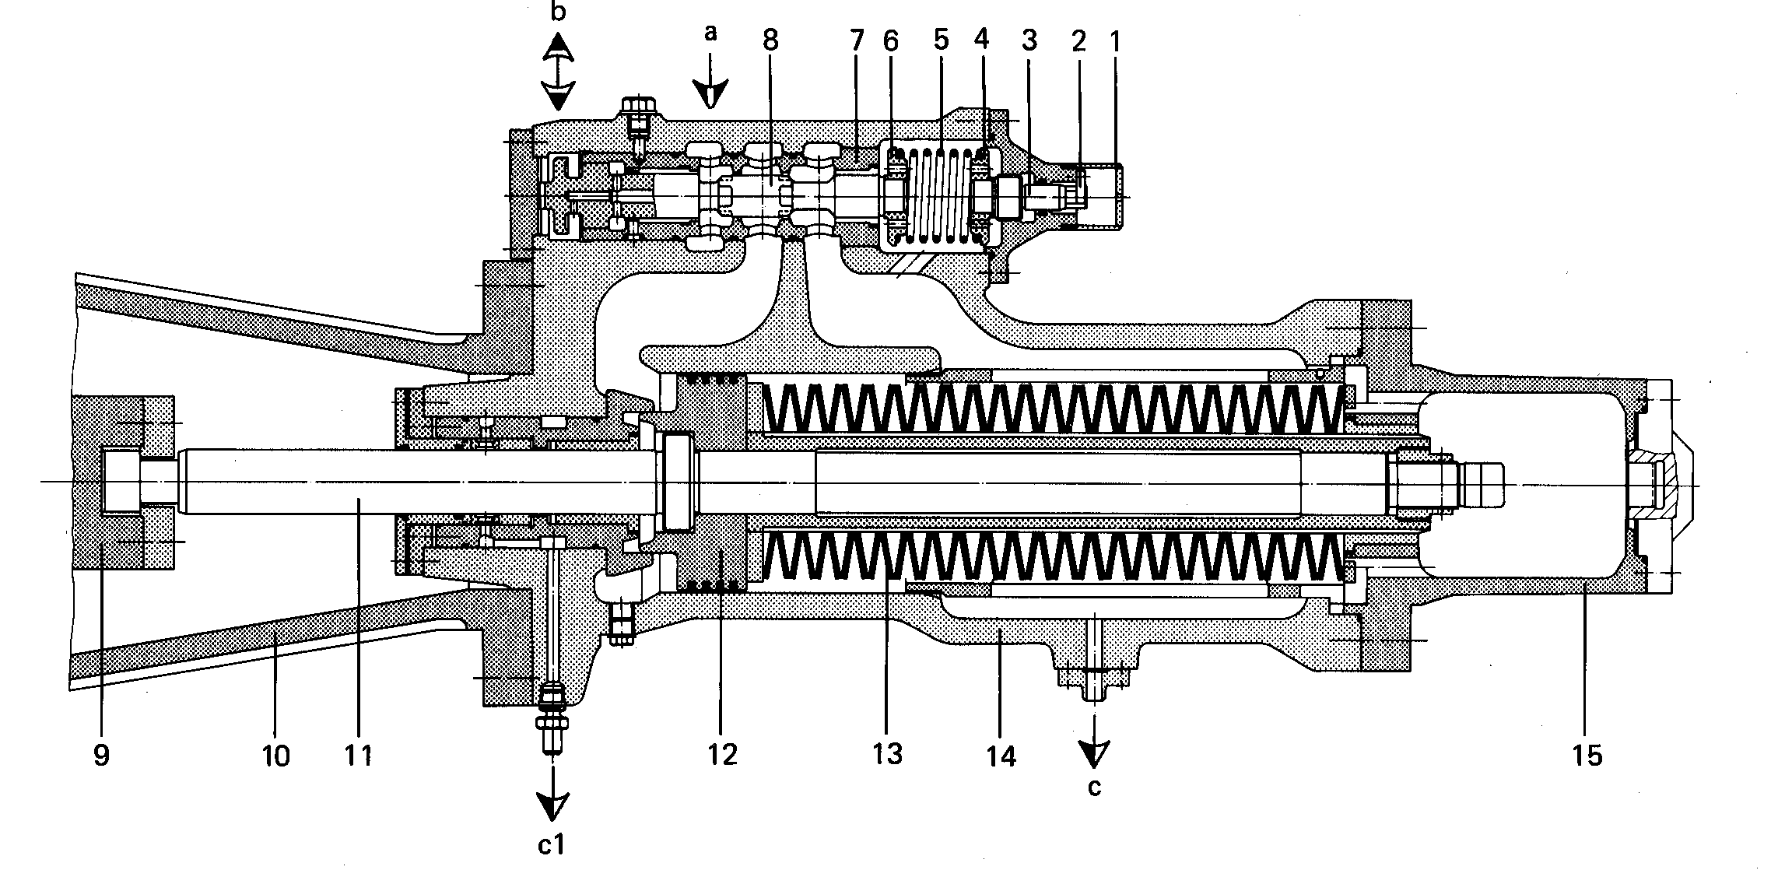

BHEL Haridwar
5.1-0824-00
- Protecting cover 11 Piston rod
- Special washer 12 Piston
- Threaded bolt 13 Disc spring stack
- Spring support 14 Casing
- Compression spring 15 Cover
- Spring support
- Valve bushing a control oil
- Pilot Valve b signal oil
- Coupling c oil drain
- Yoke c1 Leakage oil
- Coupling

