Lines
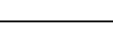 | -continuous line - flow line
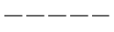 | -dashed line - pilot, drain
 | -envelope - long and short dashes around two or more component symbols.

Circular
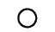 | -large circle - pump, motor
 | -small circle - Measuring devices
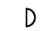 | -semi-circle - rotary actuator

Square
 | -one square - pressure control function  -two or three adjacent squares - directional control

Diamond
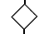 | -diamond - Fluid conditioner (filter, separator, lubricator, heat exchanger)

Miscellaneous Symbols
 | -Spring
 | -Flow Restriction

Triangle
 | -solid - Direction of Hydraulic Fluid Flow
 | -open - Direction of Pnematic flow

Pumps and Compressors

Fixed Displacement hydraulic pump
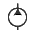 | -unidirectional
 | -bidirectional

Variable displacement hydraulic pump
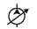 | -unidirectional
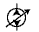 | -bidirectional

Compressor

Motors

Fixed displacement hydraulic motor
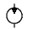 | -unidirectional
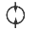 | -bidirectional

Variable displacement hydraulic motor
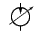 | -unidirectional
 | -bidirectional

Pneumatic motor
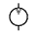 | -unidirectional
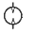 | -bidirectional

Rotary Actuator
 | - hydraulic
 | - pneumatic

Cylinders

Single acting cylinder
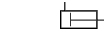 | -returned by external force
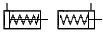 | -returned by spring or extended by spring force

Double acting cylinders
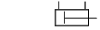 | -single piston rod (fluid required to extend and retract)
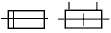 | -double ended piston rod

Cylinders with cushions
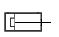 | - single fixed cushon
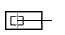 | - double fixed cushion
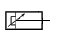 | - single adjustable cushion
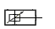 | - double adjustable cushion

Directional Control Valves

Directional control valve (2 ports / 2 positions)
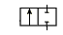 | -Normally closed directional control valve with 2 ports and 2 finite positions.
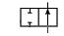 | -Normally open directional control valve with 2 ports and 2 finite positions.

Directional control valve (3 ports / 2 positions)
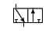 | -Normally closed directional control valve with 3 ports and 2 finite positions.
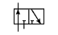 | -Normally open directional control valve with 3 ports and 2 finite positions.

Directional control valve (4 ports / 2 positions)
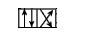 | -directional control valve with 4 ports and 2 finite postions

Directional control valve (4 ports / 3 positions)
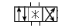 | -directional control valve with 4 ports and 3 finite postions  *-(center position can have various flow paths)

Directional control valve (5 ports / 2 positions) Normally a pneumatic valve
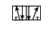 | -directional control valve with 5 ports and 2 finite postions

Directional control valve (5 ports / 3 positions) Normally a pneumatic valve
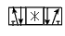 | -directional control valve with 5 ports and 3 finite postions

Proportional directional control valve

Electro-hydraulic servo valve

-The spool positions on these valves is variable allowing for variable flow conditions.
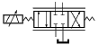 | -single-stage direct operation unit which accepts an analog signal and provides a similar analog fluid power output
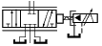 | -two-stage with mechnical feedback indirect pilot operation unit which accepts an analog signal and provides a similar analog fluid power output

Control Methods

Manual Control
 | -general symbol (without showing the control type)
 | -pushbutton
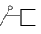 | -lever
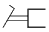 | -foot pedal

Mechanical Control
 | -plunger or tracer
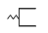 | -spring
 | -roller
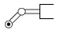 | -roller(one direction only)

Electrical Control
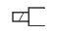 | -Solenoid (the one winding)

Pilot Operation
 | -pneumatic
 | -hydraulic

Pilot operated two-stage valve
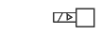 | -Pneumatic: Sol first stage
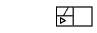 | -Pneumatic: Air pilot second stage
 | -Hydraulic: Sol first stage
 | -Hydraulic: Hyd pilot second stage

Check valves, Shuttle valves, Rapid Exhaust valves
 | -check valve -free flow one direction, blocked flow in other direction
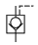 | -pilot operated check valve, pilot to close
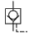 | -pilot operated check valve, pilot to open

Shuttle valve
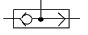 | -to isolate one part of a system from an alternate part of circuit.

Rapid exhaust valve/Pneumatic
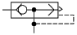 | -installed close to an actuator for rapid movement of the actuator.

Pressure Control Valves

Pressure Relief Valve(safety valve) normally closed
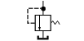 | - line pressure is limited to the setting of the valve, secondary part is directed to tank.

Proportional Pressure Relief
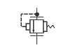 | - line pressure is limited to and proportional to an electronic signal

Sequence Valve
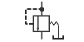 | - when the line pressure reaches the setting of the valve, valve opens permitting flow to the secondary port. The pilot must be externally drained to tank.
Pressure Reducing valve | - pressure downstream of valve is limited to the setting of the valve
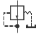

Flow Control Valves

Throttle valve
 | -adjustable output flow

Flow Control valve
 | -with fixed output (variations in inlet pressure do not affect rate of flow)
 | -with fixed output and relief port to reservoir with relief for excess flow (variations in inlet pressure do not affect rate of flow)
 | -with variable output
 | -fixed orifice
 | -metered flow toward right free flow to left
 | -pressure compensated flow control fixed output flow regardless of load
 | -pressure and temperature compensated
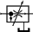 | -with variable output and relief port to reservoir

Flow dividing valve
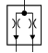 | -flow is divided equally to two outputs.

Shut-Off Valve
-Simplified symbol

Accumulators
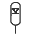

Filters, Water Traps, Lubricators and Miscellaneous Apparatus

Filter or Strainer
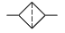

Water Trap
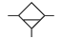 | -with manual drain
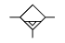 | -with automatic drained

Filter with water trap
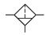 | -with manual drain
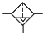 | -automatic drain

Air Dryer
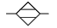 | refrigerant, or chemical removal of water from compressed air line

Lubricator
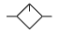 | -oil vapor is indected into air line

Conditioning unit
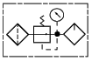 | -compound symbol of filter, regulator, lubricator unit
 | -Simplified Symbol

Heat Exchangers
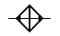<> | -air or water cooled unit designed to remove heat from oil returning to reservoir

