Types of Bearings
There are many types of bearings, each used for different purposes. These include ball bearings, roller bearings, ball thrust bearings, roller thrust bearings and tapered roller thrust bearings.
Ball Bearings
Ball bearings, as shown below, are probably the most common type of bearing. They are found in everything from inline skates to hard drives. These bearings can handle both radial and thrust loads, and are usually found in applications where the load is relatively small.
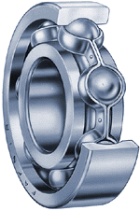
Photo courtesy The Timken Company
Cutaway view of a ball bearing
In a ball bearing, the load is transmitted from the outer race to the ball, and from the ball to the inner race. Since the ball is a sphere, it only contacts the inner and outer race at a very small point, which helps it spin very smoothly. But it also means that there is not very much contact area holding that load, so if the bearing is overloaded, the balls can deform or squish, ruining the bearing.
Roller Bearings
Roller bearings like the one illustrated below are used in applications like conveyer belt rollers, where they must hold heavy radial loads. In these bearings, the roller is a cylinder, so the contact between the inner and outer race is not a point but a line. This spreads the load out over a larger area, allowing the bearing to handle much greater loads than a ball bearing. However, this type of bearing is not designed to handle much thrust loading.
A variation of this type of bearing, called a needle bearing, uses cylinders with a very small diameter. This allows the bearing to fit into tight places.
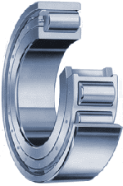
Photo courtesy The Timken Company
Cutaway view of a roller bearing
Ball Thrust Bearing
Ball thrust bearings like the one shown below are mostly used for low-speed applications and cannot handle much radial load. Barstools and Lazy Susan turntables use this type of bearing.
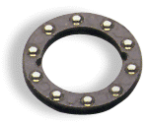
Photo courtesy The Timken Company
Ball thrust bearing
Roller Thrust Bearing
Roller thrust bearings like the one illustrated below can support large thrust loads. They are often found in gearsets like car transmissions between gears, and between the housing and the rotating shafts. The helical gears used in most transmissions have angled teeth -- this causes a thrust load that must be supported by a bearing.
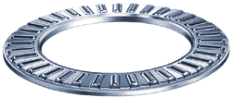
Photo courtesy The Timken Company
Roller thrust bearing
Tapered Roller Bearings
Tapered roller bearings can support large radial and large thrust loads.
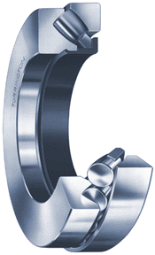 | 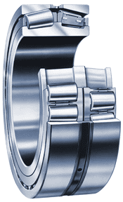
Photo courtesy The Timken Company
Cutaway view of (left) a spherical roller thrust bearing and (right) a radial tapered roller bearing
Tapered roller bearings are used in car hubs, where they are usually mounted in pairs facing opposite directions so that they can handle thrust in both directions.

