Chapter 3 - The bearing damage analysis methodology

Introduction
In this chapter we take a look at the processes used to undertake a bearing damage analysis. Part of that process is to discuss and understand the percentage of bearings that fail in service. Bearing damage analysis is a stepwise approach, from preparation to reporting, that if correctly carried out, can be integrated into a proactive reliability maintenance process (PRM).

Chapter learning objectives
By the end of this session, you will be able to:
- Understand the percentage of bearings that fail in service
- Understand the concept of Root Cause Failure Analysis (RCFA)
- Prepare a bearing analysis
- Perform a bearing analysis including reporting
- Position bearing analysis as part of Proactive Reliability Maintenance (PRM)

Bearing Failures
In a article by Englel and Winter (1979), it is stated that only 0.5% of the total volume of bearings produced, fail in service. However, in most industrial applications this percentage can be considerably higher and most failure are a result of maintenance and installation issues.

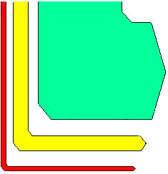
90.0 % outlive their machines
9.5 % are replaced for preventive reasons
0.5 % are replaced because of failures
TOTAL
0.5%
of total volume produced

Figure 1: Percentage of bearing failures.
"Wälzlagerschäden, ant. Antriebstechnnik" 18 (1979) Nr. 3.
By: L. Engel & H. Winter.

From the 0.5% of all bearings that fail in service, the failure causes broken down as follows:
36% are attributed to Lubrication – This could be the wrong choice of lubricant, including for example wrong viscosity or additives. It could also be the right lubricant applied incorrectly. Remember to distinguish between "lubricant" and "lubrication". The lubricant is the product used to lubricate the bearing whereas lubrication is the process of administering the lubricant.
34% are attributed to Fatigue – Premature bearing damage can come from misapplication, or an external influence such as misalignment or unbalance.
16% are attributed to Miscellaneous – Starting with bearing storage, the way you handle the bearing has a profound affect on its life. Improper installation, such as forced mounting and impact/shock loading, will cause the rolling elements to damage the raceways. Keep in mind that the shock loads on other parts of the system affect the whole system, so avoid force mounting a sheave onto a shaft that has the bearings already mounted.
14% Contamination – Includes any foreign material entering the bearing and components, such as moisture and solid particles.
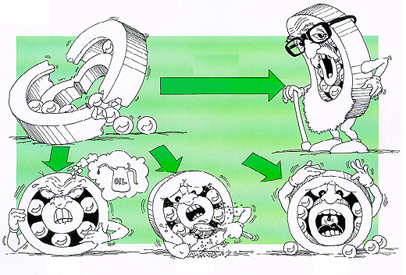
36%
14%
16%
34%

Figure 2: Percentage of bearing failures by causes.

Root Cause Failure Analysis (RCFA)

Root Cause Failure Analysis is a method to determine the primary cause of a failure
or a problem and to eliminate it.

It’s finding the true cause of the problems instead of focusing on the apparent causes.

The true or root cause of bearing damage and failure can be hard to see. Without a
trained eye and a good method of reading the bearing damage, you could fix things
that might clear up some minor problems, but the root cause will reoccur.

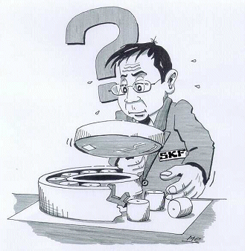

Here is a simple example:

Problem: Your car’s engine overheats and shuts down.
What caused the engine to overheat?

Observation: The water pump belts were loose.

Solution: Tighten the belts. Problem is fixed.

End of Analysis ?

WRONG!

Why is this analysis wrong?
- It is only a partial analysis.
- Nothing was done to find out why the belts were loose.
- A partial analysis leaves you with a problem that will come back again and again and again...

For real problem solving, the real cause(s) needs to be found:
Observations:
- The engine overheated and shut down.
- The water pump belts were loose.
- The belts are in good physical condition.

Analysis:
- The water pump (A) sends coolant through the engine and evacuates heat
through the radiator (B).
- The belts (C) drive the water pump.
- The engine crankshaft (D) drives the belts.
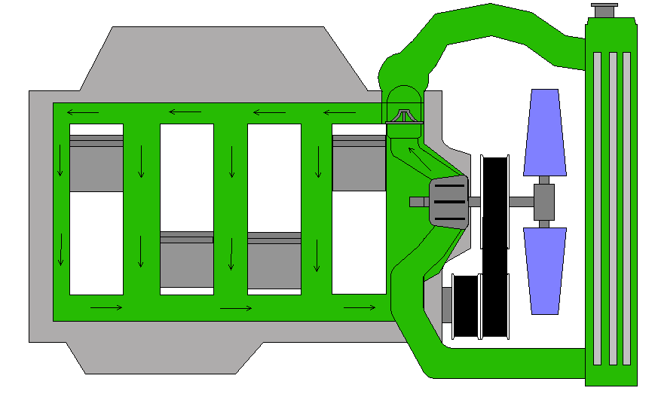
A
B
C
D

Figure 3: A simplified diagram of an engine cooling system.

Cause of overheating:
- The belts are not tight enough. But why?

The TRUE cause of failure:
- The belts were not tight enough because the threads of the tensioning bolt were stripped.

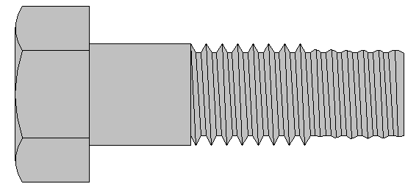

Solution:
- Replace the tensioning bolt AND
- Verify and correct all procedures and operating conditions.

Are we finished here? Are there more questions to be asked?
Keep asking why!

Q. Why was the bolt stripped?
A. The mechanic over tightened it

Q. Why was it over tightened?
A. The mechanic did not use torque wrench

Q. Why did the mechanic not use a torque wrench?
A. He was not trained properly

Q. Why was he not trained properly?
A. It costs time and money

In order to fix this, various organizational procedures need to be reconsidered.

Bearing Analysis Preparation

In situ inspection
This should be done in order to find out information such as:
- What is the position of the bearing in the machine?
- What are some details about the failure (e.g., lubricant condition, contamination, shaft and housing condition, frame)?
- If possible, measure the actual radial and axial clearance

- What are the positions of the broken parts?

- What are the consequences of the failure, secondary damage occurring etc.?

Dismounting and retaining the bearing for inspection
This is important in order to prevent or minimise further damage, and to protect the parts from further deterioration such as corrosion. Take (digital) pictures before and after dismounting!

SKF (dis)mounting guidelines -> http://www.skf.com/mount/

Information gathering by the user
Typical information that the user can gather is:
- Machine and bearing history
- Application drawings
- Vibration analysis readings if available
- Maintenance history and follow-up

Information gathering by the analyst
In order to do a complete inspection the analyst would need the following information:
- Complete bearing designation
- Bearing design (material, internal design, capacity, etc.)
- Type of machine
- Mounting techniques used
- Rotational speed
- Axial and radial loads
- Bearing operating temperature
- Ambient temperature and humidity

- Environmental contamination level
- Operating time (24hrs/day, 7days/week)
- Lubricant used and its specifications
- Lubrication specifications (method, intervals, quantities…)
- Service life (calculated, actual, mean time between failures)
- Cost generated by the failure (production loss, parts, labour…)

Agreements and arrangements
Other relevant information when outsourcing a failure analysis are:
- Contact information of the user, the manufacturer, and the supplier
- Deadlines that need to be kept
- Date when is the machine to be started again
- Disposal of the components once the analysis is completed
- Format of the final report

Bearing Analysis

Taking the bearing apart
In order to take the bearing apart, SKF suggests:
- SKF dismounting guidelines -> http://www.skf.com/mount/
- For spherical roller bearings (SRB) -> SKF Brochure TI-9003
- For (double row) deep groove ball bearings ((DR)DGBB), and double row angular contact ball bearings (DRACBB), contact SKF for advisory
- For most other bearings types, follow the SKF dismounting guidelines and the bearing falls apart easily

In general; take (digital) pictures before and after taking the bearing apart!

Preliminary Inspection
As a preliminary inspection, there are various things to be looked at such as:
- Lubricant condition (colour, presence of water, viscosity, consistency, etc.)
- Degree of corrosion, temperature effects (discoloration, deformation…)
- Any other evidence that would be lost after cleaning the bearing for inspection.

Cleaning
For cleaning, remove the excess of grease and clean the parts with a solvent. Some light surface corrosion and solid grease deposits can carefully be removed with a light abrasive pad such as wire wool, making sure not to remove any of the running marks or damage.

Visual Inspection
For the visual inspection look at each bearing component separately (inner ring, outer ring, cage, rolling elements). Take notes on the wear path observed and also of all damage observed. Identify the damage initiation points, and compare similar components with each other (inner/outer/inboard/outboard raceways, rolling elements inner/outer ring wear patterns). Eventually, perform advanced metallurgical tests such as hardness testing of all bearing components.

In general; take (digital) pictures of all relevant bearing damages!

Lubricant Analysis
- Take lubricant samples from the sides and centre of bearing.
- Do not contaminate the sample from outside sources !
- Check condition: colour, consistency, viscosity, presence of water, smell, amount of grease/oil, etc.
- Compare with a sample of new, unused lubricant.
- Use a flat spatula or other device to spread the lubricant out over a piece of clean white paper to see and feel hard materials, ferrous metal particles or other contaminates.
- Use a magnifying glass to assist in these observations.
- Use a small magnet on the underside of the white paper to show if the lubricant it is contaminated with metallic particles.

Refrain from personal opinions and too early conclusions!
Do not put the blame on things you can not verify, nor make assumptions based on rumours, personal biases or outside influences. Look at what else happens at the facility, this may give clues to problems or good practices.
It is important to work in a methodical way at the time of the analysis, in order to remain objective and avoid carrying out useless work. All the stages of the analysis must be carried out in an objective way without thinking of the probable causes of the failure. It is also very important to document each stage of the analysis by taking notes and photographs. This makes it possible to return to the analysis when necessary.

Primary and secondary failure modes
Working in reverse, make links between observed damage and establish primary and secondary damage. If needed, make a failure "flow-chart". If the damage is all secondary damage, it may be impossible to establish the primary damage.

Example:
If plastic deformation is observed during inspection, and it was caused by impact during mounting, a corrective action can be recommended. If the damage is raceway surface spalling, and is caused by a plastic deformation, again, a corrective action can be recommended.

However, if there is too much secondary damage then it may be hard to find the original cause of failure. If spalling occurs, then contamination is generated which loops back around and causes plastic deformation, which causes more surface fatigue and more spalling, etc. In the end, the bearing may be completely ruined.

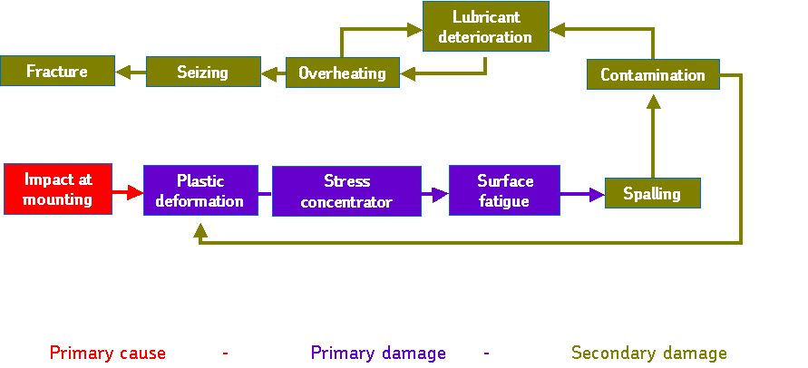
Figure 4: A cause and effect flow chart. Notion of primary and secondary damage.

Bearing Analysis Report
In the analysis report it is important to include the following sections:
- Introduction (objectives of the analysis, application history)
- Observations (list of damages, photos…)
- Bearing failure modes analysis (ISO)
- Conclusion
- Recommendations

Bearing analysis as part of proactive maintenance
Moving toward an integrated, proactive maintenance strategy starts with understanding where you are today and defining your objectives for the future.

Maximum Efficiency
Operator Driven Reliability (ODR)
Proactive Reliability Maintenance (PRM)
Predictive Maintenance (PdM)
Preventive Maintenance (PM)
Minimum Efficiency
Reactive/Corrective

Figure 5: Different maintenance strategies.
Bearing damage analysis, i.e. finding the root causes of bearing damage and recommending corrective actions, fits into a proactive maintenance regime.

SKF's solution in this regime is called Proactive Reliability Maintenance (PRM).

Proactive Reliability Maintenance (PRM)
The SKF's Proactive Reliability Maintenance process includes four basic elements. Predictive Maintenance (PdM) technologies, such as vibration and oil analysis, are applied to help identify the machine and process problems. For each detected problem, the root cause is identified and corrective actions are implemented. The findings enable the changes to be made to prevent a repeat of the same problem. The consequence of this is the Meantime Between Failure (MTBF) on machines and components is increased. Such relevant Key Performance Indicators (KPIs) are monitored on continuous basis, and are reviewed periodically.
PRM
Operational Review
Predictive
Maintenance (PdM)
Correction KPI’s
Diagnostic & Root Cause
Analysis (RCA)
Figure 6: Proactive Reliability Maintenance (PRM) process.

Proactive Reliability Maintenance (PRM) addresses repetitive failures and implements processes to prevent reoccurrences. It is a strategy that enables the organization to take complete control over what is happening on the plant floor. While traditional PdM (only) processes form a sustained maintenance loop, the PRM process forms a continuous improvement loop.

Predictive Maintenance (PdM) uses sophisticated technology systems to gather intelligence on machine condition and production processes. This may included; vibration monitoring, thermography, oil analysis, etc.
Diagnostics and RCA uses knowledge, experience and sophisticated tools to diagnose the collected data. This identifies the real root cause(s) and necessary actions, such as machine alignment, balancing, lubrication procedures, technology upgrades and training.

Correction, Key Performance Indicator's (KPI’s) are performance improvement targets. They can cover a wide range of factors, including unplanned mechanical downtime, quantity of product manufactured, plant efficiency and maintenance costs. KPI’s can also be used to determine what skills and qualifications individuals will need (e.g. lubrication, mounting/dismounting). Once a KPI is achieved, a new target is set to facilitate continuous improvement.

Operational review monitors the achievement of the KPI’s at a periodic interval. Results are documented and presented at performance review meetings. These meetings help to ensure that the process is continually refined to achieve the best balance of plant asset performance and PRM process activity cost. A well implemented and managed PRM process is the most effective method of managing risk, increasing reliability and ensuring the best possible return on plant assets.

Case Study

Introduction
A customer had a failure of an MG (Machine Glaze) cylinder bearing in a paper mill. The failure was detected with vibration analysis and a shutdown scheduled.
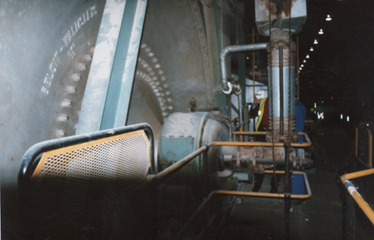
- M-G Cylinder
- 6.1 Metre Diameter
- 6.1 Metre face width
- 165 tonnes
- 12 rpm

Courtesy of Iggesund Paperboard, Workington, UK

An MG (Machine Glaze) cylinder is used on selected grades of paper. The MG Cylinder is one large hot dryer, that the paper sheet is in contact with for a long dwell time, consequently the paper sheet will start to slip, hardening the surface fibers and thus improving gloss and glazed properties on one side of the paper, e.g. manila envelopes. The problem was first observed with vibration analysis, when the velocity overall trend went up sharply.

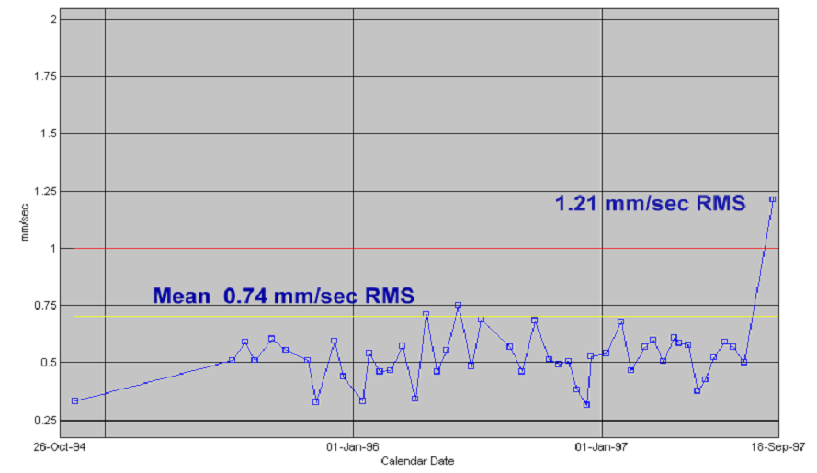
Figure 7: Vibration velocity trend deterioration.

Further readings were taken to try to identify the problem, Figure 8.

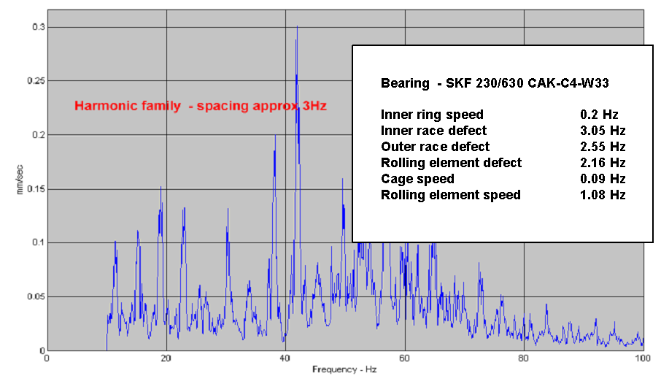
Figure 8: Spectrum analysis of the vibration velocity data.
The spectrum showed that there was a peak spaced at about every 3Hz indicating a harmonic family. This coincided approximately with an inner ring defect frequency, of 3.05Hz. This was confirmed when overlaying the inner race bearing frequencies onto the Enveloped acceleration spectrum (figure 9). Sidebands of shaft speed were also seen on the reading. This also confirmed an inner ring defect. The raised noise floor of 0.01gE on the y axis may indicate a lubrication problem.

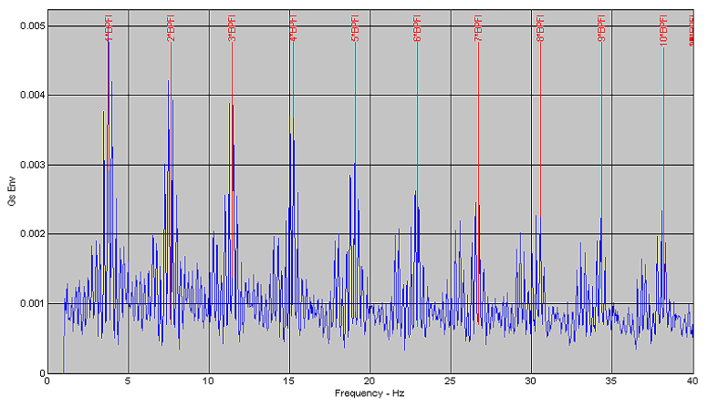
Figure 9: Enveloped Acceleration spectrum showing inner race defects.
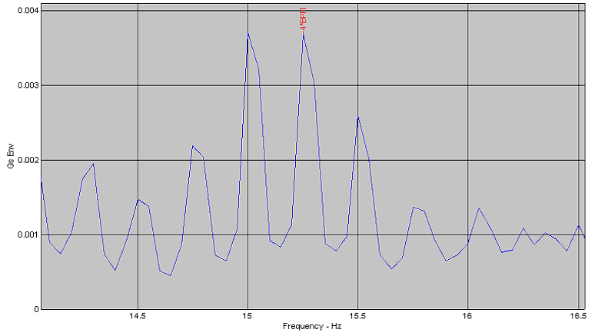

Sideband spacing = inner race speed

Figure 10: Sideband spacing of spectral peaks.

Bearing damage analysis
Because of the clear evidence of bearing damage, the bearing was disassembled. Various observations were concluded from the bearing damage analysis:

- At least two raceway fractures
- Glazed surface discoloration
- Shallow craters with crystalline surfaces
- Grey/black streaks on raceways
- Rollers had stopped turning
- Bearing turning in housing

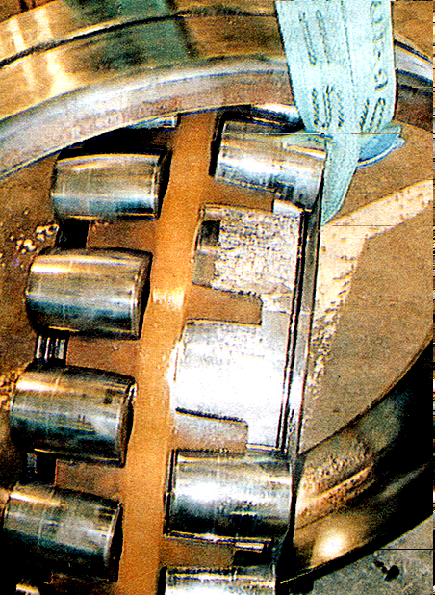
Figure 12: Disassembly of the bearing.

Conclusion
The main problem was a lubrication issue, as the viscosity of the lubricant was found to be too low for this cylinder, yet was appropriate for the rest of the dryer section.

Recommendations
A new oil system, separate from the rest of the dryer section, was recommended and installed.

Summary
The problem was identified using predictive maintenance. Next, bearing damage analysis was carried out, to discover the root cause of the problem. The corrective actions recommended overcame the problem, and any further failures due to the same problem were avoided.

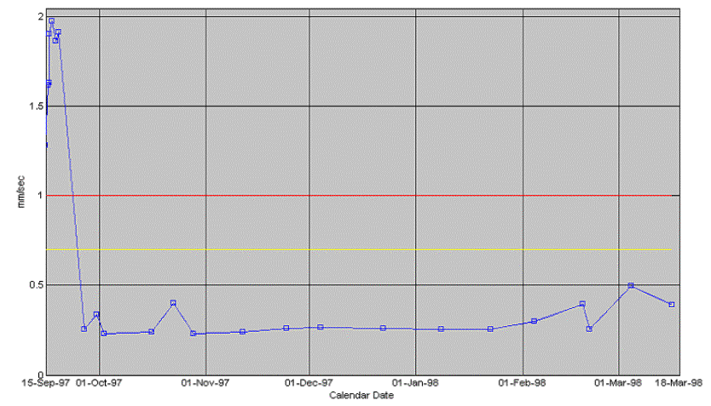

Figure 12: Vibration velocity trends after installing oil system.

